Part A:

**Title: IR Thermographic antipersonnel landmine detection and removal:**

Abstract:

From the mid-14th century, landmines still pose significant threat to soldiers and civilians leaving large areas of land uninhabitable. Existing methods of machine demining such as detonating or metal detection are not humanitarian and impair the equipment used. Our robot aims to achieve semi-autonomous humanitarian demining at minimal cost.

The robot implements IR thermography for landmine detection and tree transplanter mechanism for demining. The bot is made to navigate the selected area using remote control which can be later made autonomous using SLAM. It avoids detonating the mines while traversing over them owing to its light weight and foam track that reduce pressure on the mine. The mine is detected by IR thermography using the fact that the thermal signature of the mine is different compared to the surrounding soil. At present image processing is done using an IR camera to obtain the location of the mine. Once detected the mine is dug out by three spades (automated by linear actuators) forming a triangular prism inside the soil as in a tree transplanter.

**Questionnaire:**

1. DRDO is a prestigious organization and working on its problem statement will provide us with valuable experience. Further, the problem statement provided gives us the opportunity to explore the applications of robotics in real world problems. We also believe through this we will be able to contribute our little towards Indian defense and in effect to the nation’s development.
2. We are well versed in image processing and basics of robotics and microcontrollers.
3. Acquired second place in Shaastrotsav science fair for building a hovercraft. The project was done in a team of three under the guidance of Physics faculty, Mr. Sudhi. It used basic pascals law, wooden base and plastic body making it capable of lifting upto 80 kgs.
4. We will be submitting a concept paper presentation along with a prototype.

Part B:

**Technical proposal:**

This proposal deals with the detection of antipersonnel landmines using infrared thermography and humanitarian demining.

A land mine is a type of self-contained explosive device which is placed onto or into the ground, exploding when triggered by a vehicle, a person, or an animal.

They are of two basic types; antitank and antipersonnel. Antitank mines are usually larger and have more metallic contents compared to the plastic anti-personnel mines. Both types are buried as close to the surface as possible and are found in a variety of soils and terrain. For both types of mines, detonation is typically caused by pressure, although some are activated by a trip-wire or other mechanisms. Thus, a land-mine detector must do its job without having direct contact with a mine. Anti-tank mines do not pose a problem to humanitarian demining.

Need of a different method:

The requirements of civilian demining are quite different from those of military demining; and this affects the detection problem. During a military countermine operation, the objective is to breach a minefield as fast as possible, often using brute force.

Civilian demining method should be compatible to different mine explosives and geometric properties or preferably provide imaging information. This latter feature will enable the system to better distinguish mines from background clutter, such as rocks, metal shreds, etc. This, in turn, will reduce the false-positive alarm rate and the time wasted in trying to clear an innocuous object thought to be a mine. This method reduces damage to the machine and the threats posed to humans handling the robot by making it fully autonomous without any human intervention.

Navigation over the mine field:

SLAM:

Our idea aims to use Simultaneous localization and mapping (SLAM) technique for autonomous navigation of the robot. SLAM uses laser scan data provided by a LIDAR and odometry data from wheel encoders to prepare an occupancy grid of the environment. The map provided by SLAM, laser scan data and odometry information can be used for path planning to avoid static and dynamic obstacles. Due to the unavailability of LIDAR we have made our robot joystick controlled. The person in the base station controls the robot using a joystick. The values of the joystick are sent to a microcontroller (Arduino UNO) and these values are transmitted to another Arduino on the robot via the RF module (Radio Frequency module). The Arduino on the robot drives the motors of the robot accordingly.

RF (Radio frequency) module:

An RF module (radio frequency module) is a (usually) small electronic device used to transmit and/or receive radio signals between two devices. It consists of two components:

* RF Transmitter
* RF receiver

RF Transmitter:

An RF transmitter module is a small [PCB sub-assembly](https://en.wikipedia.org/wiki/Printed_Circuit_Board_Assembly) capable of transmitting a radio wave and [modulating](https://en.wikipedia.org/wiki/Modulating) that wave to carry data

RF Receiver:

An RF receiver module receives the modulated RF signal, and [demodulates](https://en.wikipedia.org/wiki/Demodulation) it.

A transmitter module will be controlled by the user outside the mine field and the receiver module will be placed on the bot. The range of the module we adapted is about 5 km. This allows safe distance between the robot and the human operator.

The next parameter to be considered for demining vehicle is the pressure exerted by it on the ground as it is critical that it be maintained below the detonating pressure.

Ground Pressure:

In this section we aim to avoid detonating the mine while surveying the ground by reducing the ground pressure. To do so, the area in contact with the ground while traversing has to be increased. Further, a mechanism is used to distribute the weight of the vehicle evenly to avoid triggering partially buried mines or those with low trigger pressure.

A landmine pressure fuse system is used. It consists of a base and a tread wound over it. The tread independently distributes the load to the ground. The tread has plural independent closed cell foam rubber elements. Each element is separated from adjacent elements for independently supporting only a portion of a load on the base, while other similarly independent elements support remaining portion of the load.

The independent elements of the tread are made of closed cell foam rubber formed as a tread on the base with notches between adjacent elements of the tread. The notches on the tread extend into the tread for distances greater than heights above ground of clutter and of partially buried mines or fuses.

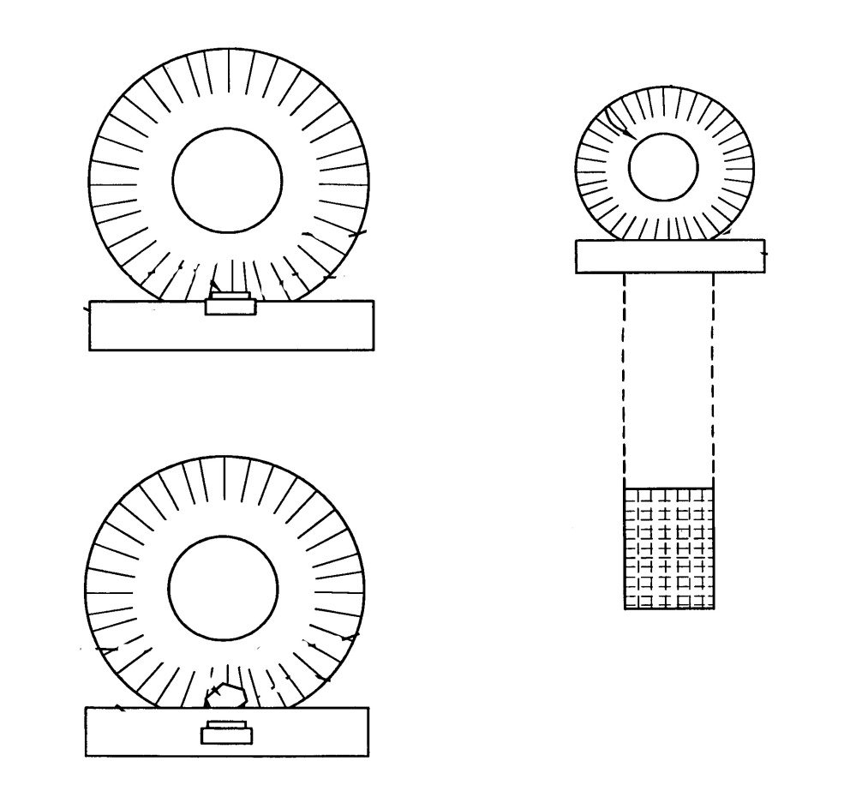

Proposed design of the treads to conform over the mine

When encountering a partially buried mine, the invention sits over and conforms to the mine that is buried in the ground. The closed cell foam retracts to allow the mine to move into the foam. Many parts of the tread touch the ground and therefore minimize the pressure on the land mine's fuse by transferring a maximum of the vehicle's weight to the ground. If the notches were not present, more of the tread would be suspended above the ground and more pressure would be dangerously on the mine's fusing mechanism.

When a completely buried mine is covered with a clutter object, such as a rock, the invention conforms to the clutter object by compressing and creates more uniform ground pressure and therefore minimum pressure on the clutter object. Because the clutter object is over the mine, minimizing the pressure on the clutter object also minimizes the pressure on the mine's fusing mechanism.

An improvement is to make a very soft tread to encourage the mine or covering clutter to move into the tread and let some part of the weight flow around the mine through the tread and onto the ground. Minimizing mine-fuse pressure is helped by letting the tread material flow around the mine's fuse to make contact with the perimeter of the mine and the ground.

Our calculations for motor torque required using the pressure exerted on the ground due to the estimated weight of the robot:

For flat land:

Mass of the bot = 7kg (approx.)

Friction coefficient of soil = 0.6

Therefore, Force = 70 * 0.6 = 42N

Radius of wheel = 5 cm

Torque required = 42 * 0.05 = 21.4 Kgcm

For slopes and small bumps:

Assuming standard angle of inclination = 15 degrees

Total force = Friction + Incline force

= (70*Sin75° )(0.6) + 70*cos75°

= 58.72N

Torque required = 30 Kgcm

IR Thermography:

The use of thermography for land mine detection has become a topic of great interest in recent years because of its flexibility. The difference in the thermal capacitance between soil and mine affects their heating/cooling rates and therefore their associated infrared emissions. Indeed, the presence of buried objects affects the heat conduction inside the soil. Consequently, the soil temperature on the ground above the objects is often different from that of unperturbed areas. This temperature signature can be measured by an IR imaging system placed above the soil area.

Infrared cameras are used to map heat leakage patterns from the ground which makes this thermography method an anomaly identification technique. From measured thermal images, it is possible to detect the presence of buried anomalies using anomaly detection techniques such as the RX algorithm, named for its authors Reed and Xiao Yu, Neuron Network, or mathematical morphology.

The main advantages of IR techniques are as follows:

1. It is safe (as IR cameras are usually placed outside the minefield).
2. We can scan a large area in a short period of time.
3. This holds for every type of mine and other buried objects, despite the amount of metal content, if any, making possible the detection of small plastic antipersonnel mines.

However, its reliability strongly depends on weather and soil conditions. Moreover, IR detection and decision-making tools are still under development.

Clearly, the degree of success of such detection technology depends on the factors that affect the formation of the thermal contrasts (signatures), such as the depth of burial; soil properties and attributes, including mine properties (size); as well as the time of day during which the measurement is carried out.

The analysis, from infrared images, of perturbations on the thermal signature of the soil is a powerful tool for the detection of the presence of buried objects, but, by itself, gives little insight in the nature of the detected targets. It is therefore necessary to develop parameter estimation and decision-making tools that enable the IR technology to distinguish signals resulting from a land mine and unrelated clutter signals.

This can be done in two steps. The first step, referred to as thermal modeling, aims at simulating the temporal behavior of the soil temperature with the presence of buried objects. The second step, referred to as inverse problem setting for landmine detection, consists of using the forward thermal model and the measured IR images to detect the presence of anomalies in the soil area and characterize them based on the estimation of their thermal and geometrical properties.

Due to the unavailability of thermographic camera we are working with ov7670 IR camera module with arduino UNO. We used an IR LED to stimulate the radiations given out by a landmine. Some of the images captures by the camera are shown below. The glaring white regions represent the IR radiation which can be isolated by above mentioned techniques.

After detecting the presence of a landmine it needs to be removed. For doing so we adopted a mechanism inspired by a tree transplanter idea.

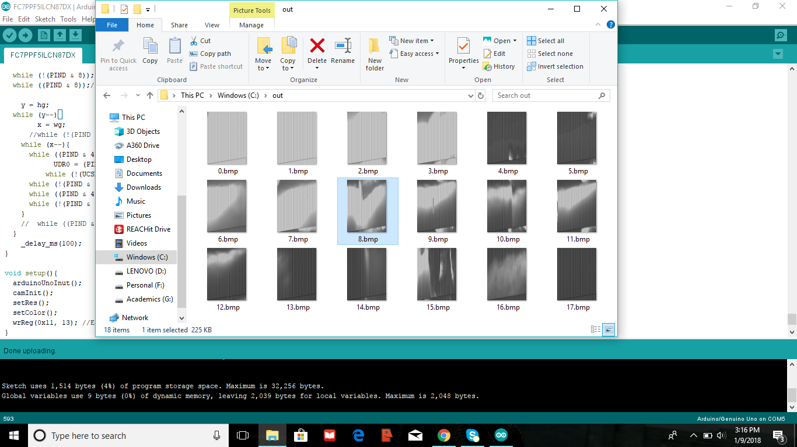

This shows the images of an IR module as captured by an IR camera.

The mechanism idea:

A typical machine consists of a number of blades (generally 3 or 4, but single or dual blade designs also exist) that encircle the tree, digging into the ground and then lifting the entire tree, including its roots and soil, out of the ground and replanting or transplanting the whole tree in the designated area.

We have chosen to actuate three such spades using one 24V electric linear actuator with a stroke length of 100mm. In this idea it is imperative, to calculate the soil digging force required for an assumed average burial depth of 7 cm for antipersonnel mines.

Digging Force:

When machine moves and digs the soil using working tools, (such as bulldozer, loader, and tractor), tool is subject to digging resistance. This resistance is much higher than resistance to machine movement so digging resistance requires deeper study.

Digging resistance consists of cutting resistance (R1) and displacement resistance of dug soil (R2), different for each tool type. Cutting resistance is tangential component of overall digging resistance. For supporting machine, bulldozers for example, cutting resistance can be formulated as:

R1 = k1 * L * h [N]

k1: specific cutting resistance (N/m2)

L: cutting tool width (m)

h: soil cutting depth (m)

Cutting resistance depends on the type of working tool (flail, tiller) and working conditions. According to soil categorization, specific soil resistance (k1) can range from 25 kN/m2 to 320 kN/m2 in the first and fourth soil category respectively.

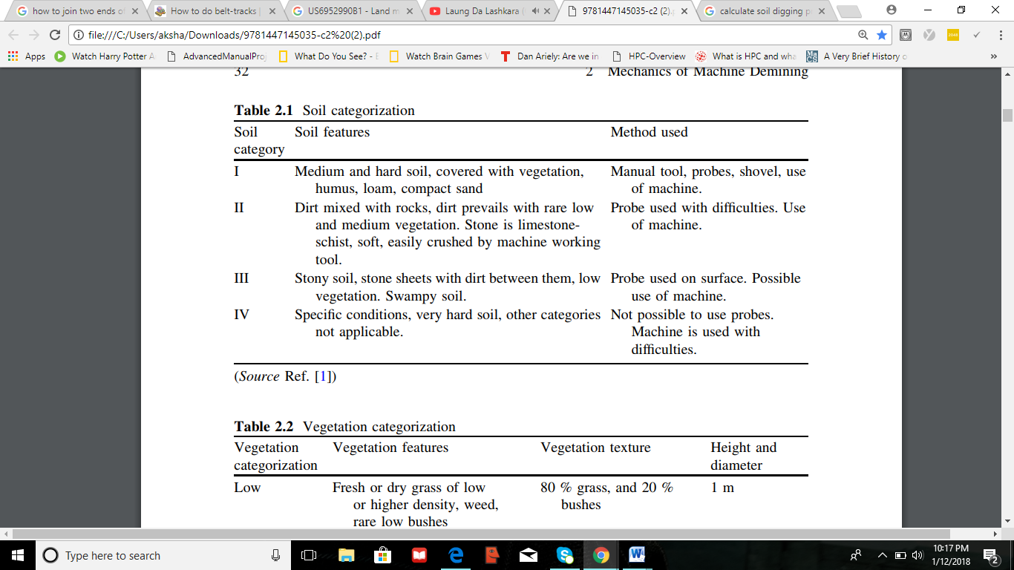

To operate in hard soil category, teeth are mounted on toll blade, which loosen the soil and decrease cutting resistance for 25 %. It is important to properly set up digging depth and adequate distance between teeth in order to achieve less resistance.

Cutting resistance is dominant in relation to machine movement resistance ( 90 % of machine power is used for digging resistance). Cutting resistance increases more due to increase of cutting depth (h), then with increase of cutting width (L). In order to achieve required efficiency on certain soil category, machine operator should adjust cutting depth ‘‘h’’ and regularly inspect tool blades.

Soil cutting resistance:

R1 = k1 * b * St  [N]

k1: specific soil cutting resistance (N/m2)

b: tool blade width, tooth

St: current cutting layer thickness

Our calculations:

Cutting resistance = Tangential component of total digging force (along the shovel)

= specific soil cuting resistance * length of cutting tool * depth

= K * l * h

K = 25 KN/m2 ( for hard or medium soil)

Mine radius = 7.5 cm

Therefore , side = 25 cm

Side (base) of shovel = 50 cm

In one shovel:

α = 68.5 at height h

Length ‘l’ is in contact

So , tan α = l/2h

Therefore , l = 5h

Resistance = K $\int_{0}^{10}{5h dh}$

*

= 625 N

Diagram of the spade and the shape formed under the soil:

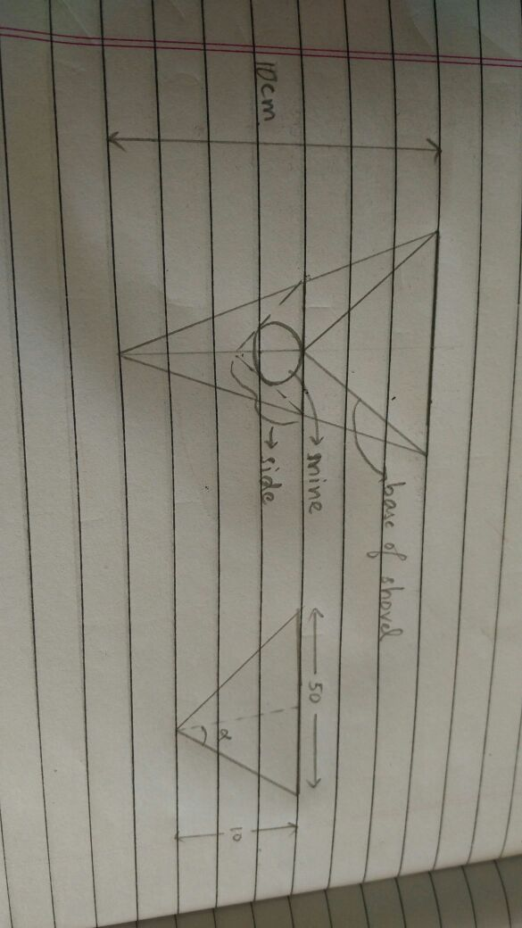

Our mechanism:

The three spades would meet under the ground forming a triangular pyramid. Then, the base in which the three spades are fitted is lifted above the ground to the height of the chassis using fork lift mechanism.

|  |  |
| --- | --- |
|  | The basic tree transplanter idea representing the movement of the links with the actuator for digging into the ground. |
|  | This model with cardboard represents the formation of the spades under the ground and the placement of the groves in the base. |
|  | This represents a prototype of the spade along with the main link. |
|  | This figure shows the first model of our design along with slider mechanism to trasnmit the force applied by the linear actuator to three symmetrical links. The spades will be joined at the end of each of the three links. |

If qualified for second level of screening:

1. We would like to work on the idea of using thermographic camera and implementing inverse thermography to differentiate between clutter and landmines. It will also help determine the geomentrical properties of the mine along with its burial depth helping us optimize the design to suit various types of landmines.
2. We would also like to research further on the use of SLAM for autonomous navigation applying laser scanner or LIDAR.

If qualified for third level of screening:

1. We will explore further on the use of LIDAR for SLAM. The odometry values are found using wheel encoders and landmarks are extracted using a LIDAR. In this technique first the robot’s position is roughly estimated using odometry values. The position of the landmarks are simultaneously found using LIDAR. Using the position of landmarks which are re-observed again and again the robot’s position is estimated. The values obtained from odometry and LIDAR is supplied to Extended Kalmann Filter which estimates the position of robot while simultaneously mapping the environment.
2. We would also like to propose a further reliable mechanism to avoid mine detonation during field traversal by avoiding moving over the mine. It can be implemented using multiple wheels and making sure only those set of wheels touch the ground which will not come directly over the mine.

To make a realisable prototype:

We can improve the materials used to build the premature model to allow better strength and durability. Further, we can work on joints and lubrication to facilitate smooth operation of the machine. Finishing a more user friendly interface and autonomous navigation will complete this idea as a realisable prototype.

**References:**

<https://ocw.mit.edu/courses/aeronautics-and-astronautics/.../1aslam_blas_repo.pdf>

<https://ti.tuwien.ac.at/cps/teaching/courses/networked-embedded.../seminar.pdf>

<https://www.electronicshub.org/arduino-rf-transmitter-receiver-module/>

<https://arduinobasics.blogspot.com/.../433-mhz-rf-module-with-arduino-tutorial.html>

<http://www.instructables.com/id/RF-315433-MHz-Transmitter-receiver-Module-and-Ardu/>

<https://patents.google.com/patent/US6952990B1/en>

<https://www.ricam.oeaw.ac.at/files/reports/11/rep11-25.pdf>

<http://journals.sagepub.com/doi/full/10.5772/50907>

<http://ieeexplore.ieee.org/document/4683351/?part=1>

<https://www.omicsonline.org/open-access/study-of-forces-acting-on-excavator-bucket-while-digging-2168-9873-1000282.pdf>

<https://www.researchgate.net/publication/302311637_Mechanics_of_Machine_Demining>